SHIVAGADHI ENGLISH SCHOOL
2nd Terminal Internal Evaluation - 2082
Class: Nursery Subject : Maths
Name___________________________ Roll. No. ___
Writing
1. Write 1 to 20.

_____ _____ _____ _____ _____
_____ _____ _____ _____ _____
_____ _____ _____ _____ _____
_____ _____ _____ _____ _____

Reading
2. 1 2 3 4 5
6 7 8 9 10
11 12 13 14 15
16 17 18 19 20

SHIVAGADHI ENGLISH SCHOOL
2nd Terminal Internal Evaluation - 2082
Class: Nursery Subject : Maths
Name___________________________ Roll. No. ___

Listening
3. Show me your two fingers.
Show me your Nose.
Show me your three pencils.
Pick up the book.
Speaking

1. How many circles are there?
2. How many cats are there ? 

3. How many apples are there ?
4. Count and say how many fingers are there?
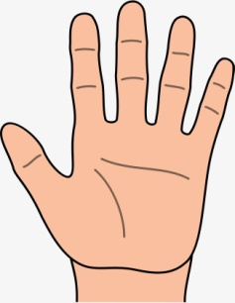

**Best of Luck**

